The Slide Rule

An Introduction
Slide rules are mechanical analog computers. Before the proliferation of the personal computer, dealing with large numbers was difficult. Slide rules made getting an approximate answer a whole lot easier, and approximate answers were usually “good enough” in most situations. Slide rules are primarily used to give rough estimates of multiplication and division problems, but can also do fancier things like square roots, cube roots, unit conversion, trigonometry, and a ton of specialized functions for architects, engineers, astronomers, and finance people. Slide rules usually look like a narrow ruler, but for today’s demonstration we will be building a circular slide rule.
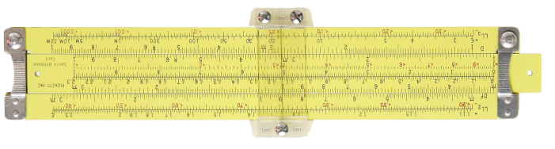 | 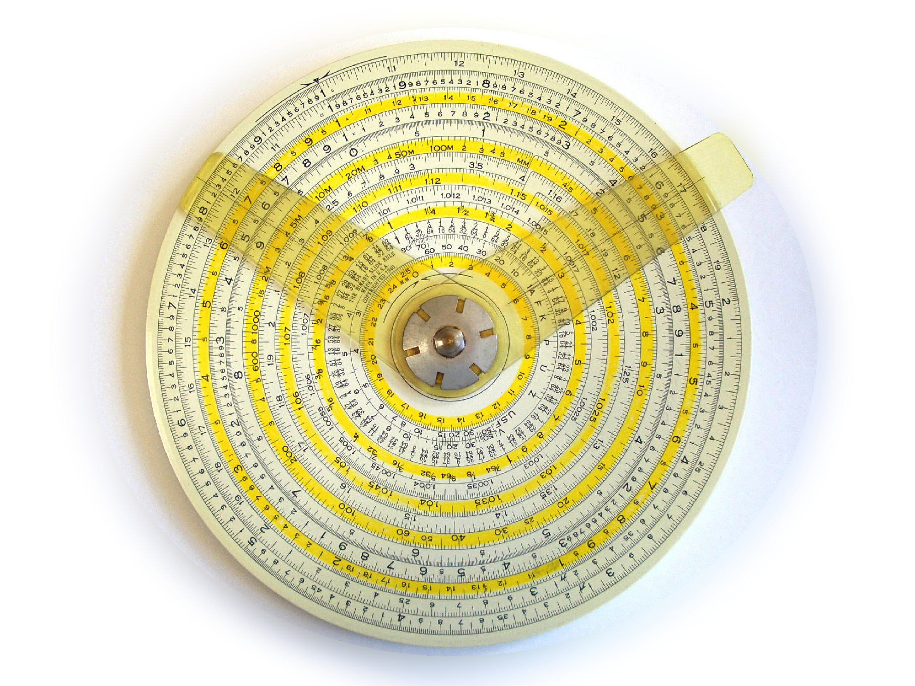
A Pickett N600-ES Slide Rule | A Gilson Atlas Calculator Circular Slide Rule

Some History
1614 – Discovery of logarithms by John Napier, a Scottish landowner known as a mathematician, physicist, and astronomer.
1622 – Invention of the slide rule by William Oughtred, an English mathematician. William is also the same person who introduced “x” as the multiplication symbol.
1859 – The modern form of the slide rule was created by Amédée Mannheim, a French artillery lieutenant at the time.
1976 - The final slide rule manufactured by Keuffel & Esser (K&E) was donated to the Smithsonian Institute in Washington, DC.
Although the last K&E slide ruler marked an end of an era, slide rules are still manufactured today. They are cheap and durable calculation tools still used among pilots, heating and air conditioning technicians, and machinists.
Slide rulers can be easily bought in auctions for about $5. However a slide rule that traveled with Apollo 11 to the moon, Buzz Aldrin’s Pickett N600-ES, recently auctioned for over $75,000.

Why Slide Rules Work
Slide rules work by allowing you to add or subtract numbers on scales to perform multiplication, division, or other operations. This works because logarithms are exponents. Although you don’t need to understand everything about exponents and logarithms to use a slide ruler, you should know that in order to multiply two numbers, you add their exponents; to divide you subtract the exponents.
For Example: 2² x 2³ = 2⁵ = 32 and 2⁵ / 2² = 2³ = 8
The “C” and “D” scales on a slide rule use base 10 logarithms to scale the distance between the marks. The statement LOG(1) =0 is the same as saying 10⁰=1 and LOG(2)=0.301 is the same as 10^{0.301}=2.
If this is over your head, don’t worry about it – you can learn more about this later. For now, you should concentrate on how to use a slide rule.

A Slide Rule Joke
Did you hear about the engineer who made a bed in the shape of a slide rule?
He slept like a log!

Build a Slide Rule
First construct the slide rule by cutting it out and gluing it to construction paper or paper plates. The smaller “C” scale should fit inside of the larger “D” scale. Attach the rings together with a paper clip, small rivet, or eyelet. Notice that the scales have numbers spaced the same distance apart by lining up the 1’s.
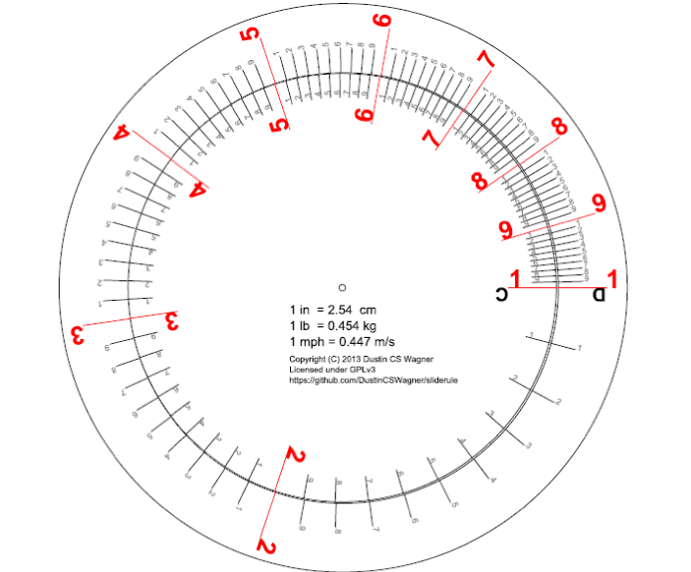

To perform multiplication, align the first multiplier to the 1 on the D scale, find the second multiplier on the D scale, and read the product off of C. Let us compute 1 x 2 = 2. Align 2 on C to match 1 on D. Look around the scale, do you see that 2x2=4, 2x3=6, and 2x4=8? Notice that 2 x 1.5 = 3, and that 2*6 = 1.2 when that happens we must move the decimal place one, 2x6=12.
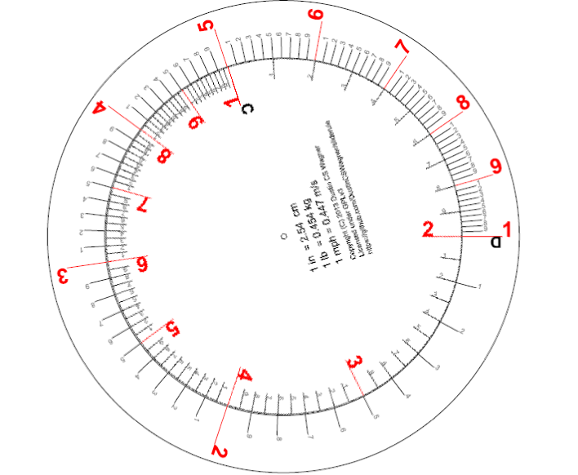
To perform division, align the denominator (the one on bottom) on the C scale to the 1 on the D scale. The numerator is on the C scale, and the answer is read off of D. For example, align 3 on C to 1 on D. Notice that 9 / 3 = 3 and 1.2 (a.k.a. 12) / 3 = 4.

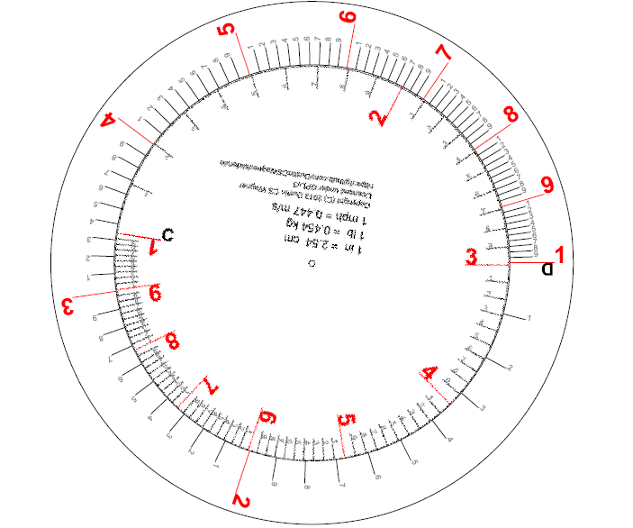
Now that we have the basics down, you can work the following problems or you can create your own multiplication and division problems. Remember that you will only be able to get 2 or 3 significant digits out of this tool, but that will usually be close enough!

2 x 1 =  2 x 3 =  4 x 5 =  5 x 5 =  2.2 x 2 =  22 x 2 =  4.1 x 3 =  3.1 x 2.3 =  7.3 x 1.5 =  95 x 7.3 = | 9 / 3 =  12 / 3 =  20 / 5 =  25 / 5 =  2.5 / 5 =  1.2 / 3 =  4.1 / 1.2 =  88 / 2.3 =  73 / 1.5 =  87 / 3 =
2, 6, 20, 25, 4.4, 44, 12.3, 7.13, 10.95, 693.5 | 3, 4, 4, 5, 0.5, 0.4, 3.4, 38.3, 48.7, 29

